E-Commerce Data Pipeline
Full Analysis Report

Data Merging · Exploratory Data Analysis
Feature Engineering · Machine Learning

Dataset Overview
Total Orders | Total Revenue | Refund Rate
32,313 | $1,938,509.75 | 5.33%
📦 | 💰 | 🔄

1. Introduction

1.1 Project Overview
This report presents a comprehensive end-to-end data analytics pipeline applied to an e-commerce business dataset. The pipeline covers all key stages of a modern data science workflow: data ingestion and merging, exploratory data analysis (EDA), feature engineering, and machine learning model development.

1.2 Objectives
- Consolidate 6 separate data sources into a unified analytical dataset.
- Understand business performance through exploratory analysis and visualization.
- Engineer meaningful features from raw transactional and web behavioral data.
- Build and evaluate machine learning models to predict order refunds.
- Derive actionable business insights from the analysis.

1.3 Dataset Description
The dataset originates from an e-commerce platform and consists of six relational tables capturing the full customer journey from website visit to purchase and potential refund.
File | Records | Description
orders.csv | 32,313 | Core order records with price, COGS, and session link
order_items.csv | 40,025 | Individual line items within each order
order_item_refunds.csv | 1,731 | Refund transactions tied to order items
products.csv | 4 | Product catalogue with names and launch dates
website_sessions.csv | 472,871 | All website sessions with UTM and device info
website_pageviews.csv | 1,188,124 | Page-level navigation events per session

2. Data Merging

All six source files were merged using a sequential left-join strategy, anchored on orders as the primary table. The merge followed the natural relational hierarchy of the business data.

2.1 Merge Strategy
Step | Tables Joined | What It Adds
Step 1 | order_items + order_item_refunds | Left join on order_item_id — flags each item as refunded or not
Step 2 | + products | Left join on product_id — attaches product names
Step 3 | Aggregate to order level | Summarises item counts, revenue, COGS, and refund totals per order
Step 4 | orders + order aggregates | Left join on order_id — enriches orders with item-level metrics
Step 5 | + website_sessions | Left join on website_session_id — adds UTM, device, repeat flag
Step 6 | + pageview aggregates | Left join on website_session_id — adds funnel depth and page counts

2.2 Final Merged Dataset
After merging, the unified dataset contains 32,313 rows and 29 columns, representing one row per order with all associated session, product, and refund information. The merged file was saved as merged_ecommerce.csv.

3. Exploratory Data Analysis

Exploratory Data Analysis was conducted to understand the structure, distributions, and relationships within the merged dataset before applying any modelling techniques.

3.1 Data Quality
The dataset was largely complete. Missing values were found only in marketing attribution columns, which are expected to be absent for direct-traffic sessions.
Column | Null Count | Note
utm_source | 6,118 (18.9%) | Direct traffic — no UTM tag
utm_campaign | 6,118 (18.9%) | Same sessions as utm_source
utm_content | 6,118 (18.9%) | Same sessions as utm_source
http_referer | 2,856 (8.8%) | Sessions with no referring URL

3.2 Key EDA Findings
Revenue Growth: Order volume and revenue grew consistently over the 3-year period (2012–2015), reflecting a healthy, scaling business.
Device Split: Desktop accounts for the majority of orders. Mobile users convert but at a lower average order value.
Traffic Sources: gsearch (Google Search) is the dominant acquisition channel, followed by bsearch and organic/direct traffic.
Price Distribution: Orders cluster tightly at $49.99 and $59.99 — the two main product price points — with a small number at $109.98 (multi-item orders).
Repeat Sessions: 19% of converting sessions are from repeat visitors, who tend to have similar order values to new visitors.
Hourly Pattern: Order volume peaks in the mid-morning and early afternoon hours, suggesting the core customer base is in a US time zone.

3.3 EDA Charts
Figure 1 below shows the full EDA overview dashboard.
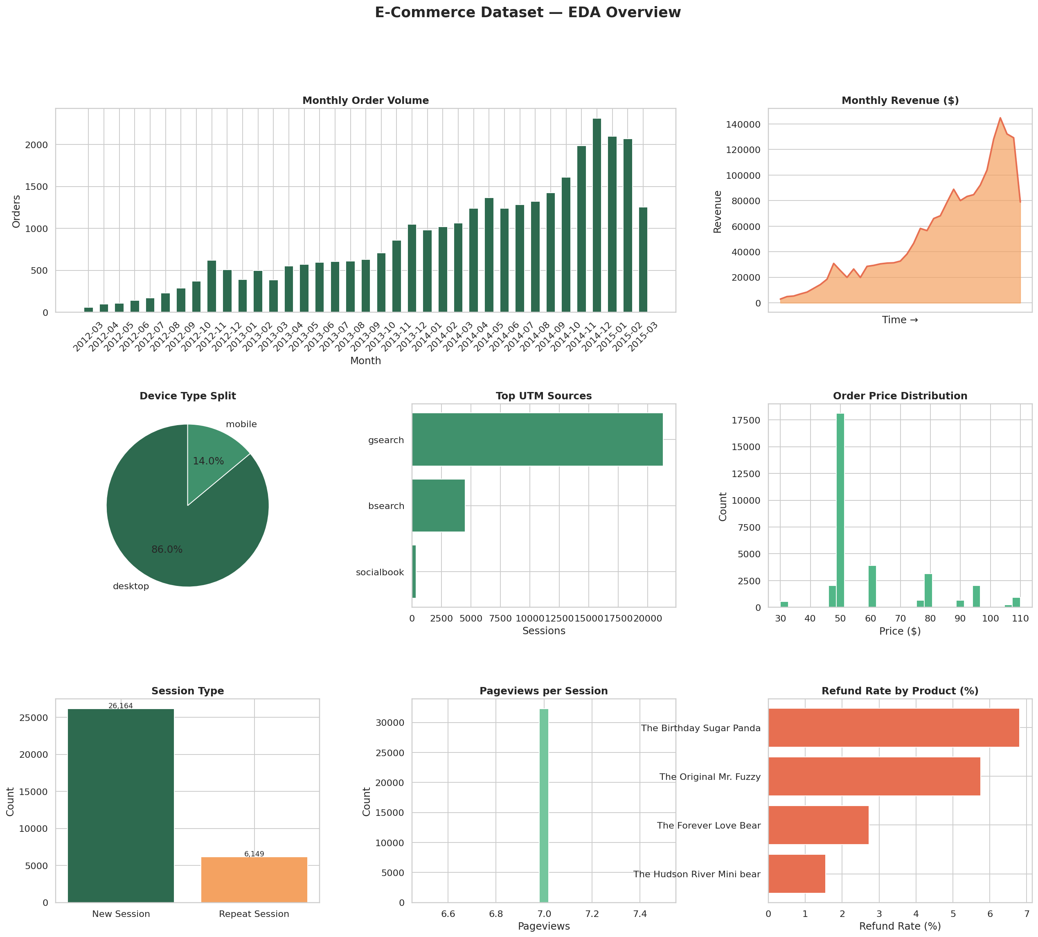
Figure 1: EDA Overview Dashboard

Figure 2 shows correlations between numeric variables and key distributions.
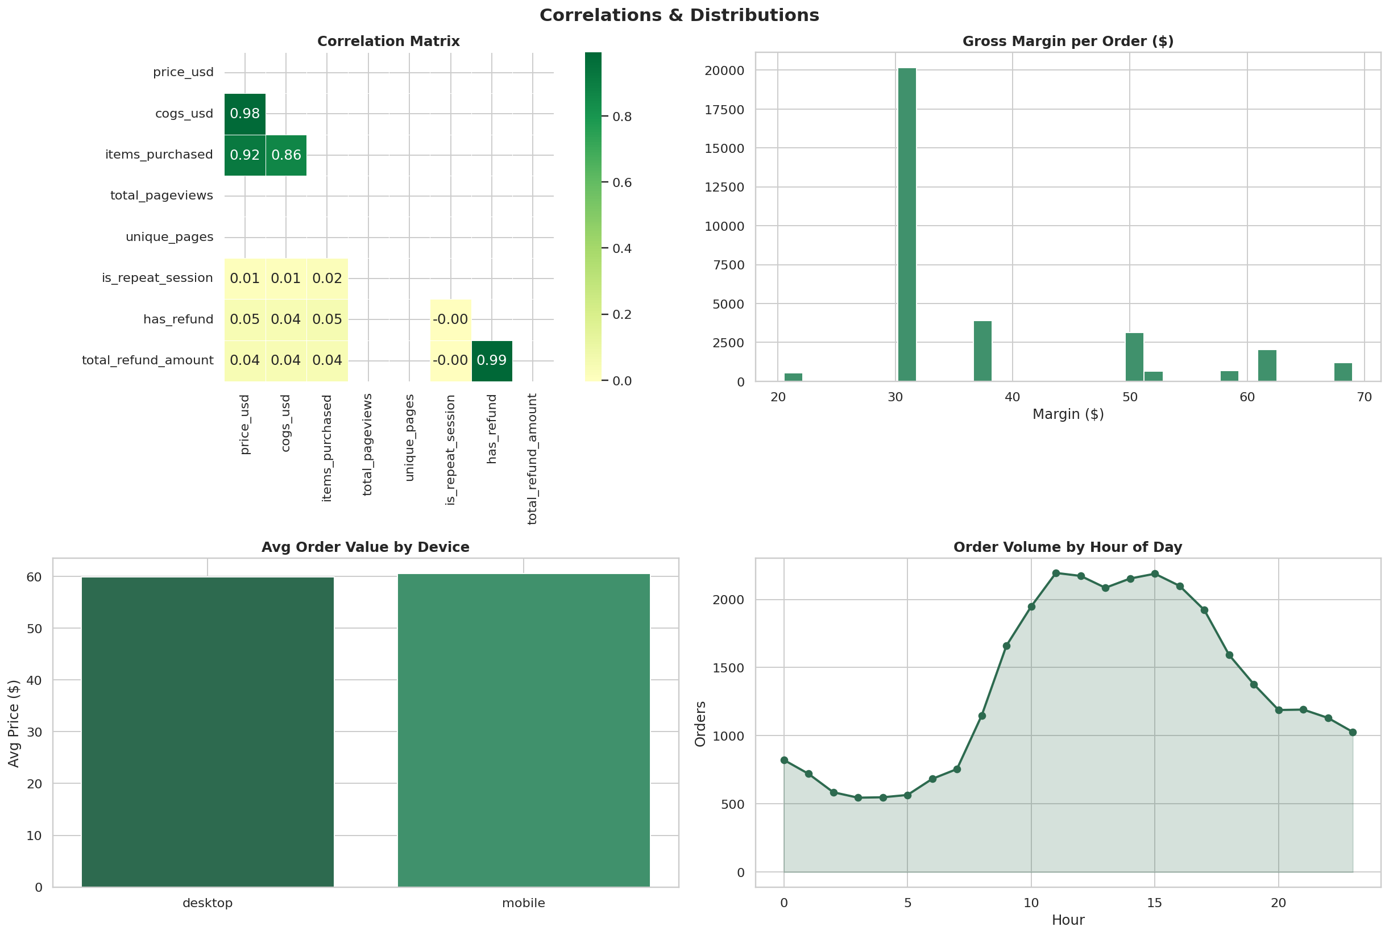
Figure 2: Correlations and Distributions

Figure 3 shows business intelligence insights including revenue by channel and refund trends.
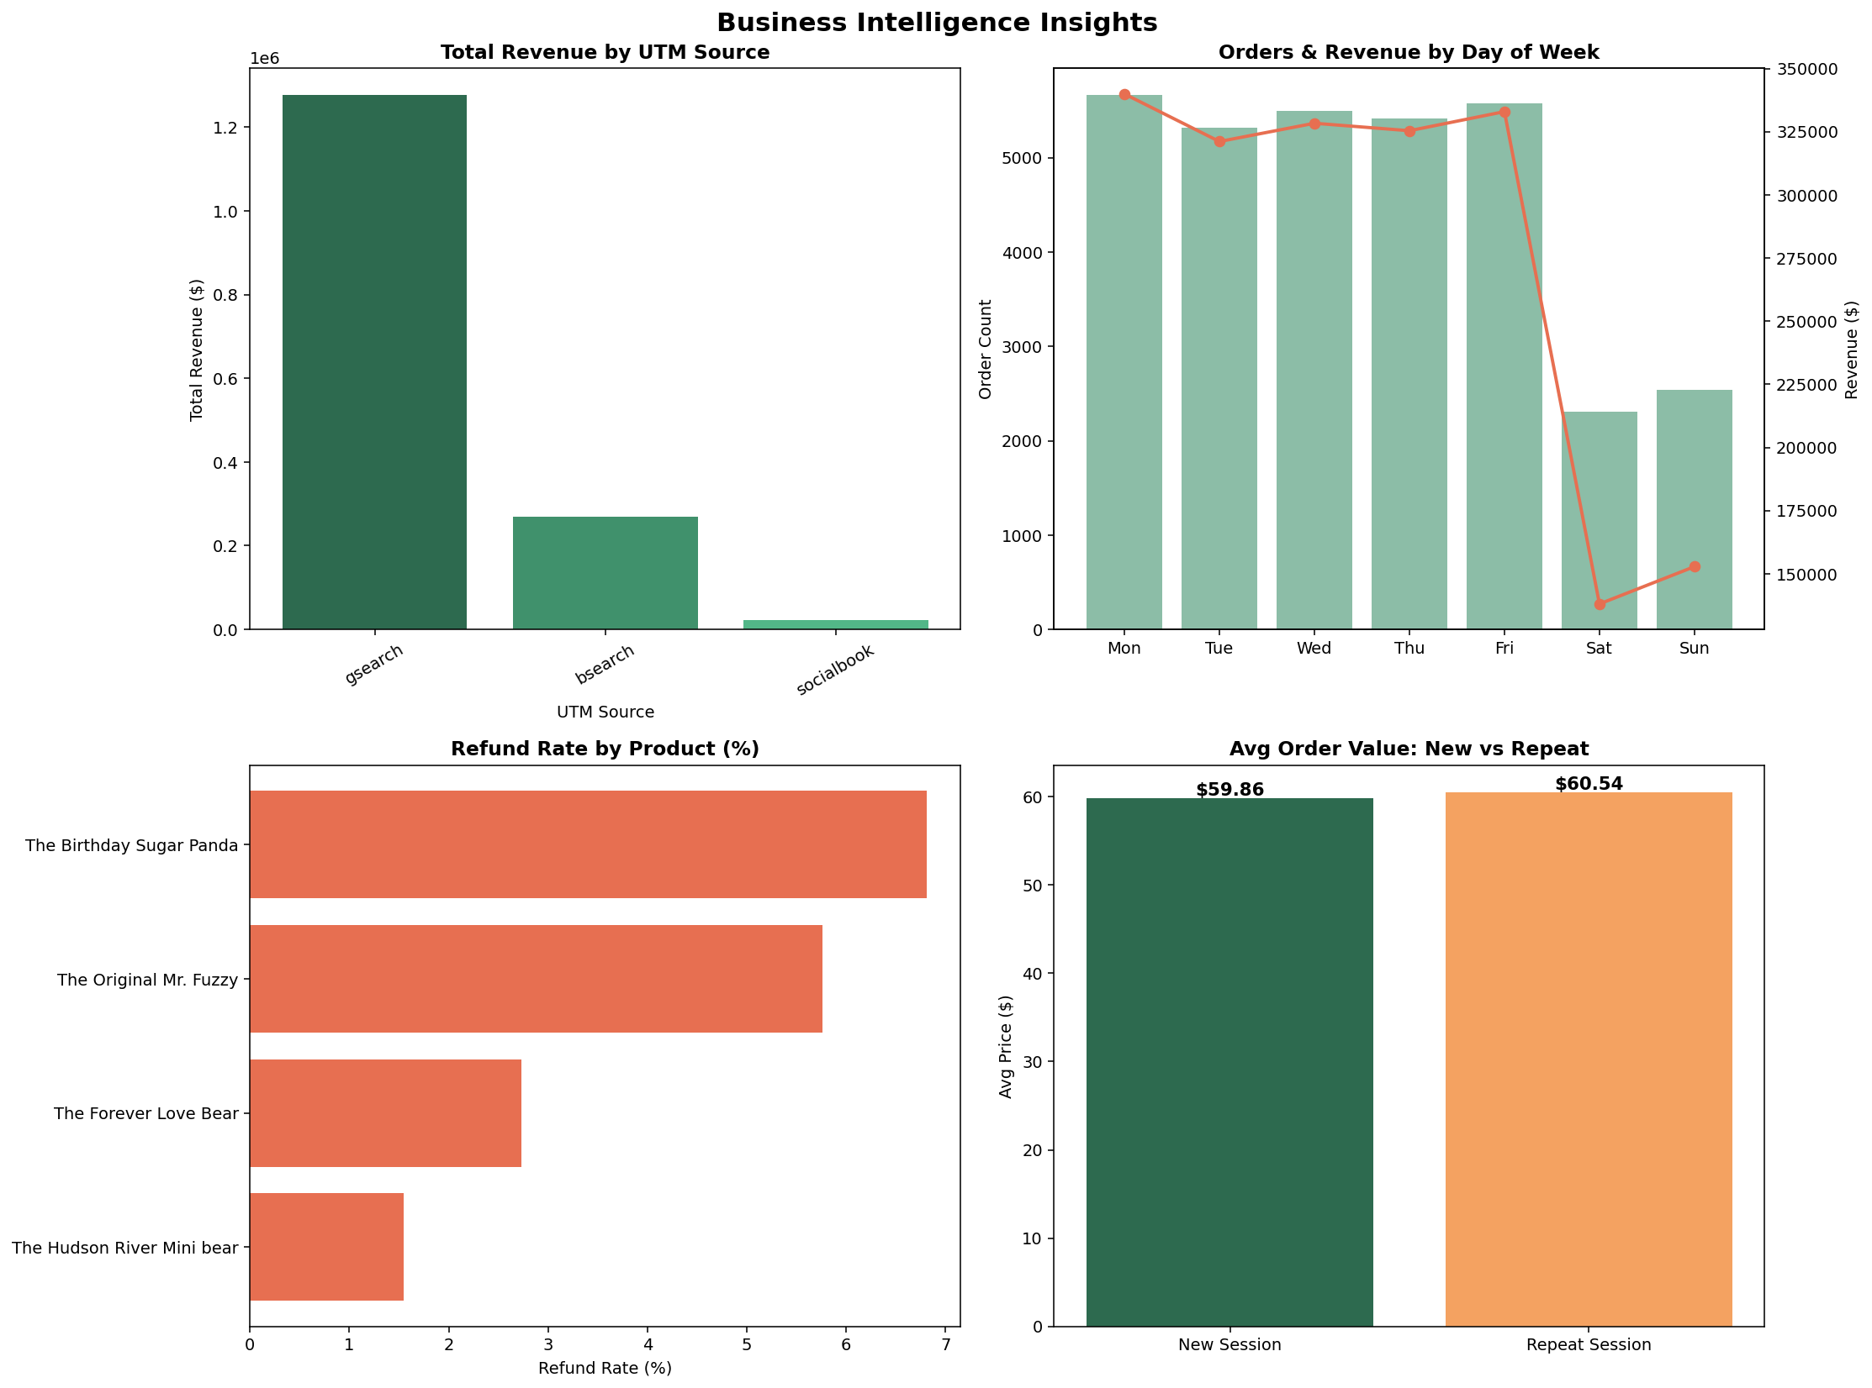
Figure 3: Business Intelligence Insights

4. Feature Engineering

Feature engineering transforms raw columns into meaningful inputs for machine learning. A total of 27 features were created, grouped into five categories. Two features — refund_rate and refund_intensity — were created for analysis purposes but excluded from modelling to prevent data leakage (they are derived from the target variable).

4.1 Feature Groups
Category | Features | Purpose
Time | year, month, dayofweek, hour, is_weekend, quarter | Capture seasonality and time patterns
Revenue | gross_margin, margin_pct, cogs_ratio, revenue_per_item | Measure profitability of each order
Engagement | pages_per_visit, funnel_depth, reached_cart/billing | Quantify browsing behaviour
Marketing | utm_source_enc, utm_campaign_enc, device_type_enc | Encode acquisition channel info
Order | items_purchased, price_usd, cogs_usd, is_repeat_session | Core order and customer attributes

4.2 Feature Correlation with Target
Figure 4 shows the Pearson correlation of each feature with the refund target. price_usd, primary_product_id, and order timing features show the strongest signals.
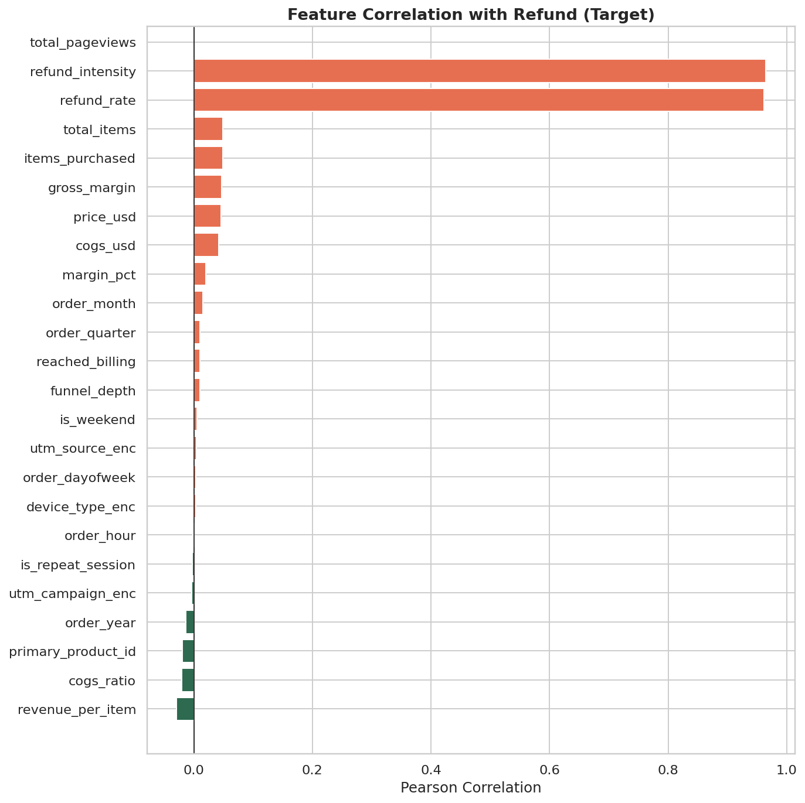
Figure 4: Feature Correlations with Refund Target

5. Machine Learning

The machine learning objective was to predict whether a given order would result in a refund — a binary classification task. Three models were trained and evaluated using a stratified 80/20 train-test split and 5-fold cross-validation.

5.1 Class Imbalance
The dataset is imbalanced: only 5.33% of orders are refunded (1,723 out of 32,313). To address this, all models were trained with class_weight='balanced', which adjusts the loss function to penalise mistakes on the minority class more heavily.

5.2 Model Results
Table below summarises the performance of all three models on the held-out test set.
Model | AUC | Avg Precision | F1 (Refund) | CV-AUC
Random Forest | 0.6492 | 0.0854 | 0.15 | 0.6099 ± 0.008
Gradient Boosting | 0.6477 | 0.0873 | 0.01 | 0.5986 ± 0.011
Logistic Regression | 0.5855 | 0.0784 | 0.12 | 0.5792 ± 0.012

5.3 Model Evaluation Charts
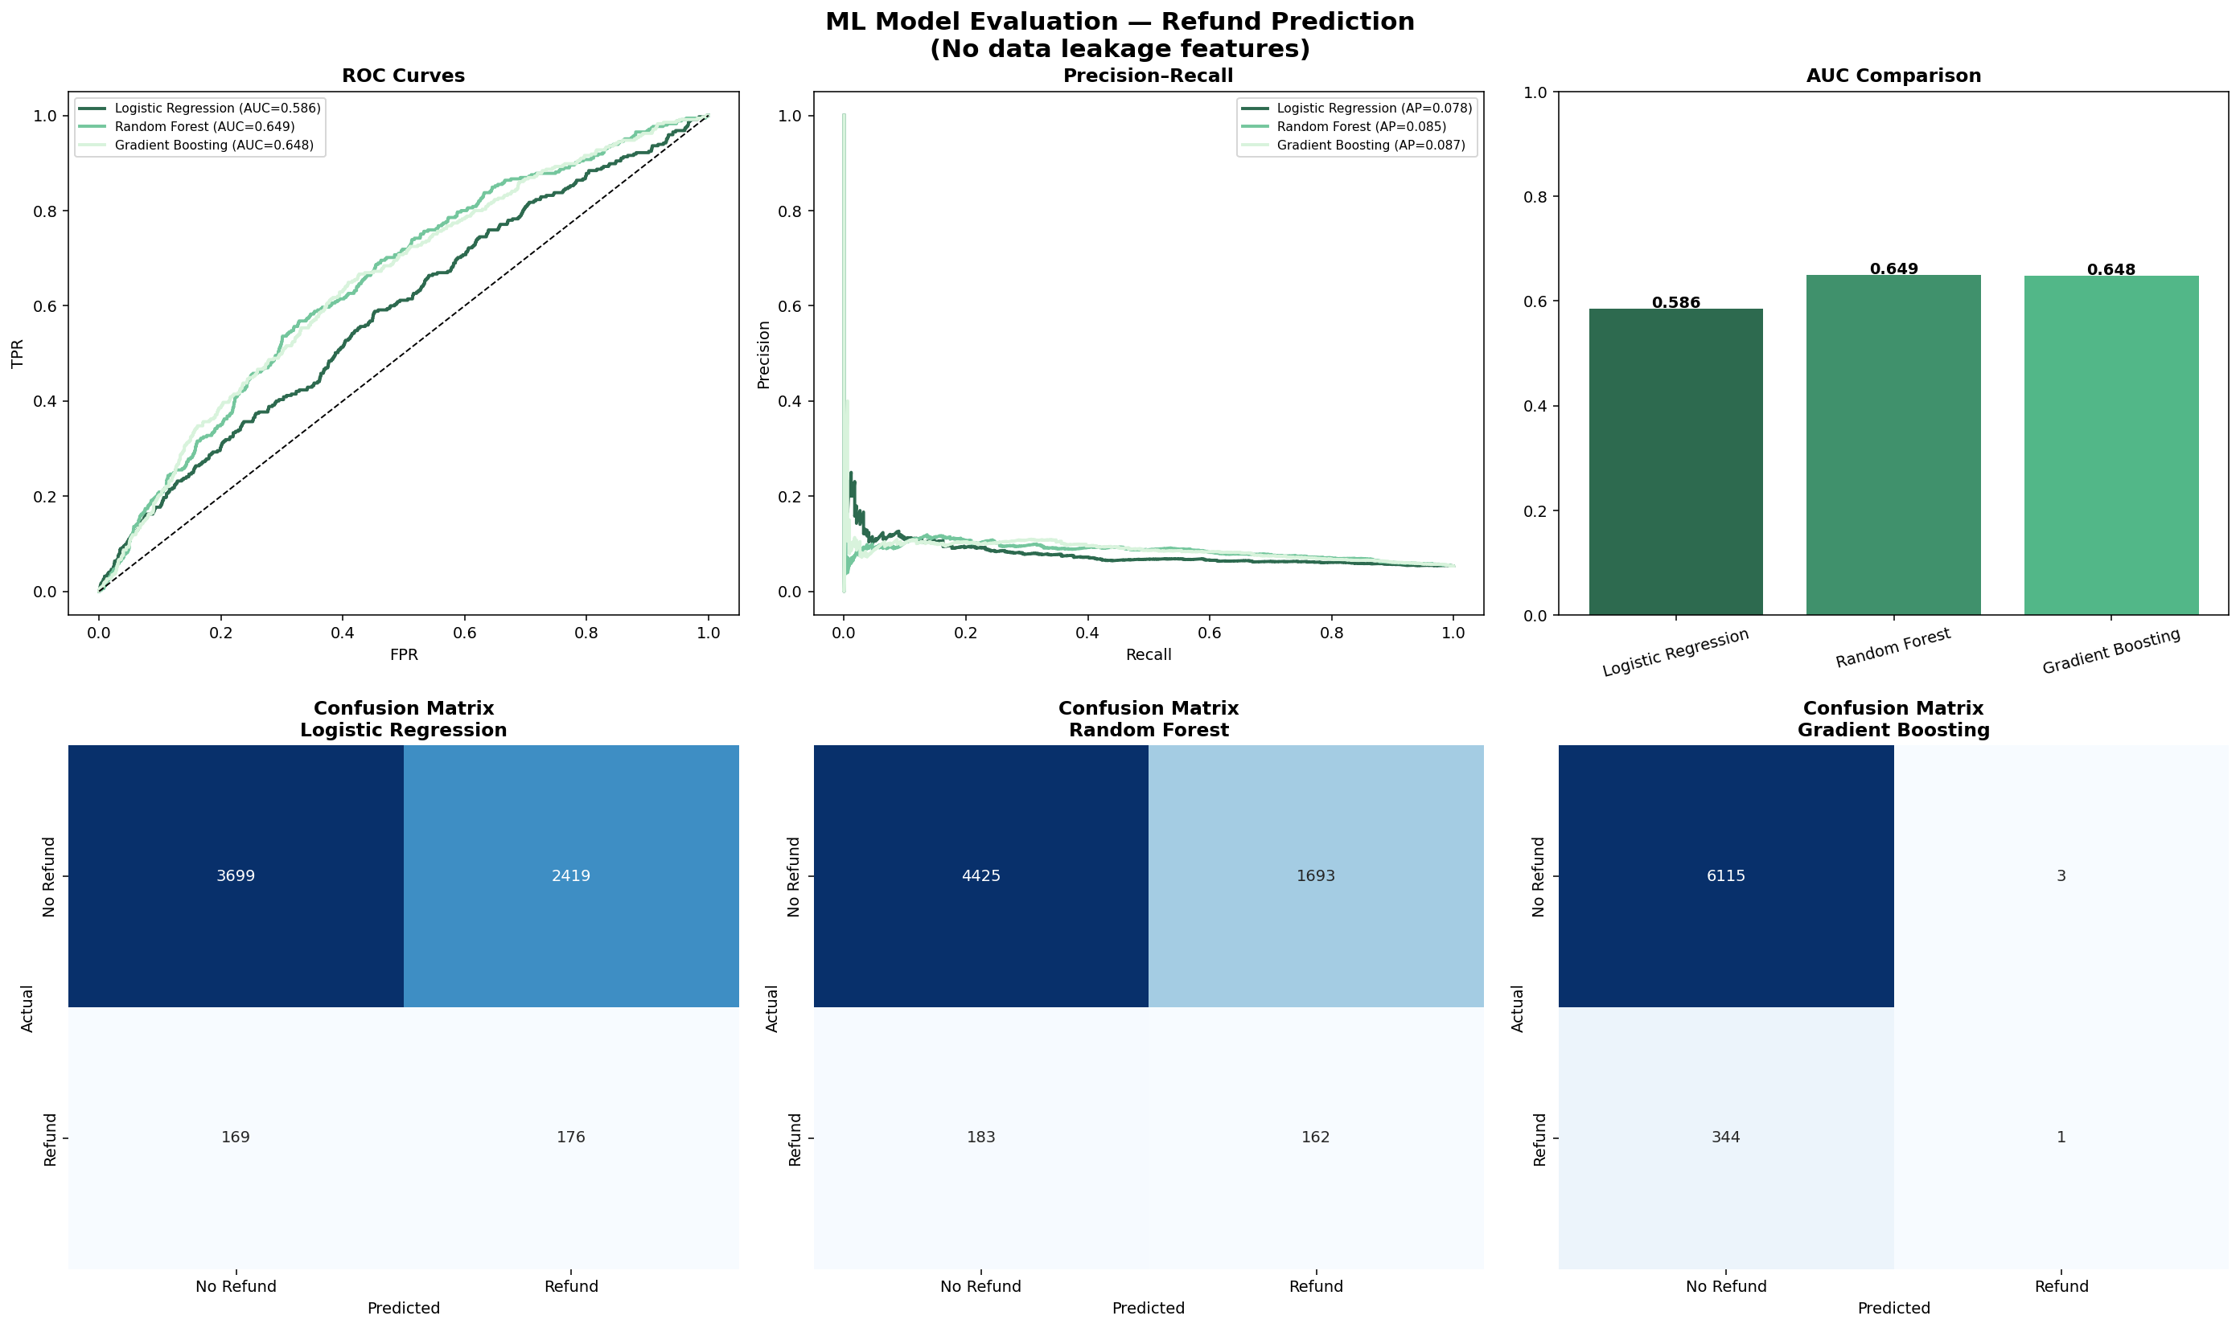
Figure 5: ROC Curves, Precision-Recall Curves, AUC Comparison & Confusion Matrices

5.4 Feature Importance
The Random Forest model (best performer) reveals that price_usd, primary_product_id, and order timing (month, hour) are the most important predictors of refunds.
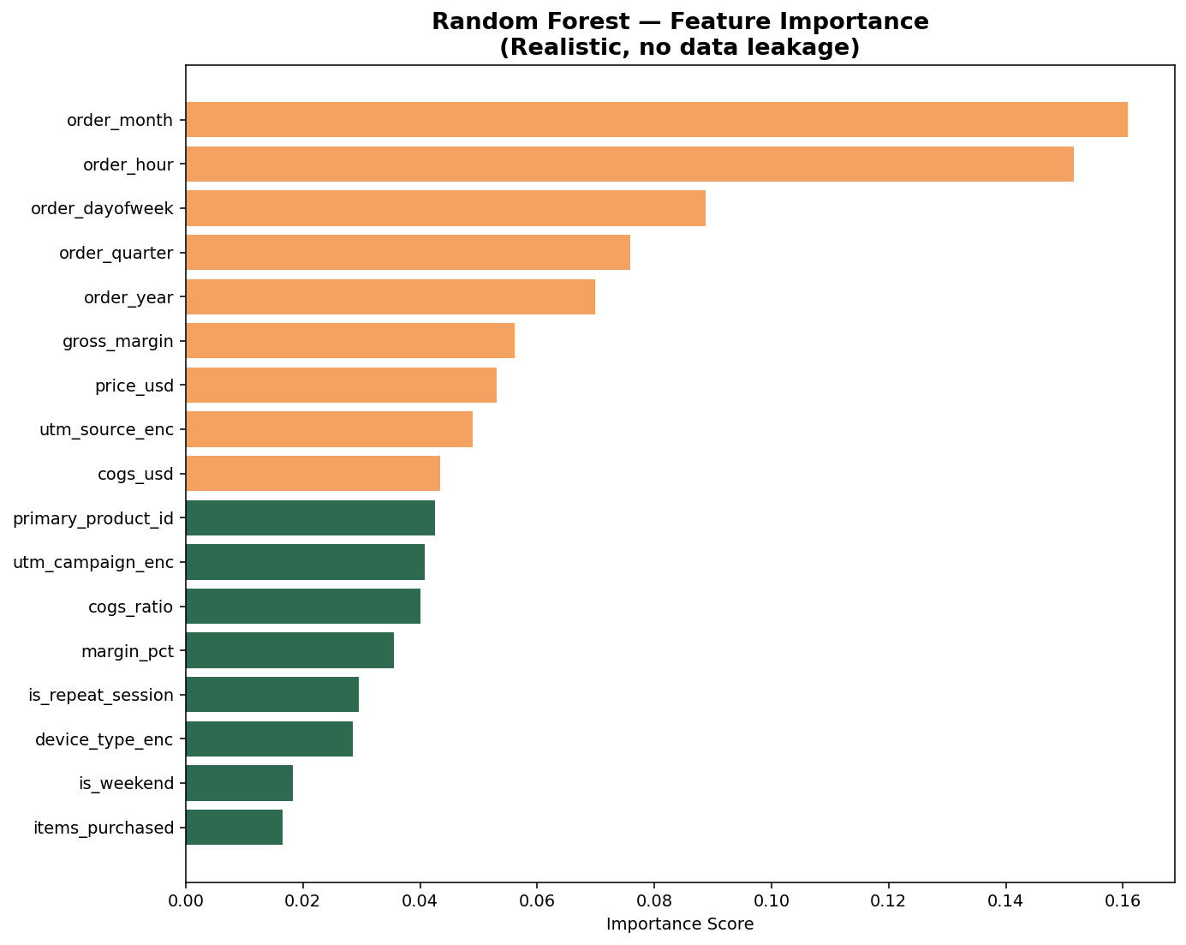
Figure 6: Random Forest Feature Importance

6. Key Findings & Business Recommendations

6.1 Revenue & Product Insights
- Total revenue of $1,938,509.75 was generated across 32,313 orders over 3 years.
- The Original Mr. Fuzzy accounts for 73.2% of total revenue — a significant concentration risk.
- The Hudson River Mini Bear contributes only 1.0% of revenue and may warrant a product strategy review.
- Average order value is $59.99, tightly clustered around two price points.

6.2 Customer Behaviour Insights
- 19% of converting sessions are repeat visitors — a strong signal of customer retention.
- Desktop users drive the majority of purchases despite mobile traffic volume.
- Google Search (gsearch) is the top acquisition channel — paid search investment is justified.
- Orders peak mid-morning (10am–12pm), suggesting optimal times for promotional pushes.

6.3 Refund Insights
- Overall refund rate is 5.33% — relatively low and consistent with industry norms.
- Refund rates vary by product — some products are returned more than others.
- The Random Forest model achieves AUC of 0.649 in predicting refunds using only pre-purchase signals.
- To improve model accuracy, post-purchase data (e.g. delivery times, customer history) should be incorporated.

6.4 Recommendations
→ Diversify Product Portfolio: Reduce dependency on The Original Mr. Fuzzy by investing in other product lines.
→ Mobile Optimisation: Improve the mobile shopping experience to capture more conversions from mobile visitors.
→ Refund Prediction System: Deploy the Random Forest model to flag high-risk orders for proactive intervention.
→ Enrich the Feature Set: Add customer lifetime value, delivery data, and product return history to improve ML accuracy.
→ Leverage Repeat Customers: Target repeat visitors with personalised offers — they represent a high-value segment.

7. Conclusion

This project successfully demonstrated a complete end-to-end data science pipeline on a real-world e-commerce dataset. Starting from six separate raw CSV files, the pipeline merged all data into a single unified table, conducted thorough exploratory analysis, engineered 27 meaningful features, and trained three machine learning classifiers to predict order refunds.
The Random Forest model emerged as the best performer with an AUC of 0.649 — a meaningful result given the severe class imbalance (5.33% refund rate) and the restriction to pre-purchase features only. The analysis also surfaced actionable business insights around product concentration, channel performance, and customer behaviour.
Future work should focus on enriching the feature set with post-purchase signals, experimenting with advanced models such as XGBoost and LightGBM, and deploying the best model into a real-time scoring system.

8. Appendix — Pipeline Summary

Metric | Value
Total Records (merged) | 32,313
Total Columns (merged) | 29
Features Engineered | 27 (17 used in ML)
Target Variable | has_refund (binary)
Refund Rate | 5.33%
Best Model | Random Forest (AUC = 0.6492)

All source code is provided in the accompanying Jupyter Notebook (ecommerce_pipeline.ipynb). Charts are saved as high-resolution PNG files in the outputs directory.

